**CHAPTER 1**

**INTRODUCTION**

**Background of the Study**

Over the year, mobile phones have changed from simple communication device to an operative tool that has become the focal point of many businesses due to amazing new features. Increasing advance in mobile technology, high speed data access and the interactive interface have turned mobile computing into a whole new experience for users.

According to Upwork Global 2015 one of the most compelling motivations for this is the improvement of portable applications. The mobile app development company has seen one of the biggest growths in the last decade by developing apps for android. Now these mobile apps have become an integral part of our lives and we rely on them in more than one way.

Diabetes can happen in anybody. However, people who have close relatives with the disease are somewhat fairly more inclined to develop it. Other risk factors of occurring diabetes are high cholesterol, high blood pressure and physical inactivity and the risk for developing diabetes is increasing as people grow older. People who are over 40 and overweight are more likely develop diabetes. Patient Trusted medical information and support. According to American nurses association,1996 lifestyle should be characterized by maintaining dietary habits and increasing physical activity is most important for health priority. Diet, exercise and counseling were types of prevention programmers with the diet habit and exercise being the most efficacious. Some of the studies are demonstrated excellent and their result, maintaining the effects of the healthy lifestyle.

As per measurements from 2011, the American Diabetes Association (ADA) evaluates that 25.8 million kids and grown-ups in the United States have sort 1 or sort 2 diabetes.1 Diabetes represents a substantial financial weight on the U.S. human services framework, with assessed related expenses in 2007 of $174 billion.1 Proper patient instruction and administration are significant on the grounds that diabetes is a dynamic illness that prompts full scale and micro vascular difficulties, including coronary illness, stroke, hypertension, nephropathy, and neuropathy. ([Oman Med J](https://www.ncbi.nlm.nih.gov/pmc/articles/PMC3464757/),2012)

In conjunction with the trend, applications on mobile phones to access certain health assistance is one marvelous idea. Mobile application had finally made their way into the medical field, contributing to a faster and more efficient way to assist us with medicines.

**Statement of the problem**

The preliminary statement of this study is being studied and summarizes all essence issues, reason, and answer and also organized the entire topic.

This study seeks to answer the following problems.

1. Diabetic patients lack awareness of their diet plan.

2. No monitoring of medicinal intake.

3. Patients lack contact details of their respective doctor when they need immediate assistance.

**Objectives of the Study**

The general objective of this study is to create a mobile app that will help to resolve the current issues that being said in the statement of the problem. The objectives of the study are:

1. To create a web application that gives most recent and valuable information about their diet plan.
2. To create a web application that gives reminder about food intake and medicine intake.
3. To create a web application that would easily contact their specified doctor if they need assistance.

**Scope and Limitations**

This project will help diabetic patients monitor their daily food and medicinal intakes. This is an online system that will help users be more aware of their diabetic health. The features to be implemented in the system are medicine intake reminder, Step-by-step information about their diet plan, SOS contact.

**Limitations**

In spite of the items mentioned above there were some unavoidable limitation. The web application cannot cover any other physical and medical conditions except diabetic case.

**Significance of the Study**

The study will help the proponents discuss the significance in terms of user, community, researcher and future researcher significance.

**Diabetic Patients**

The diabetic patients as the use of the system will gain knowledge and be aware about their physical condition, Monitor their status regarding on their condition.

**Community**

The community for improving their awareness in diabetes and importance of their healthy lifestyle and maintaining the proper routine and physical activities.

**Future Researchers**

This will serve as a future or as the base reference for the future researcher. This might add and improve the system and helps the future researcher thinking abilities and program.

**Researchers**

The researchers were able to develop a mobile application for diabetes that would help the user gain knowledge about their current condition and maintain their healthy lifestyle.

**Operational Definition of Terms**

**Create patient profile –** In this section we’re the user will input his or her personal information.

**Generate health status** – For this section is to allow the user to generate their health status and to know about their current conditions.

**Contact details –** Allow the users to input contacts and stored.

**Diet plan –**In this section we're the user can view their diet food to maintain their health that cause for diabetic.

**CHAPTER 2**

**REVIEWS OF RELATED LITERATURE AND SYSTEM**

**RELATED LITERATURE**

**Android**

Android is a Linux-based working framework for cell phones. It was produced by the Open handset Alliance, drove by Google. Google monetarily sponsored the underlying designer of the product, Android Inc., and later bought it in 2005. The advancement of the Android dissemination in 2007 was declared with the establishing of the Open Handset Alliance, a relationship of eighty-six equipment, programming, and media transmission organizations gave to propelling open models for cell phones. Google discharges the Android code as open-source, under the Apache License. The Android Open Source Project (AOSP) is entrusted with the safeguarding and further advancement of Android. Moreover, Android has larger community of developers composing application that widen the functionality of the devices. Google can download from third-party sites to through online stores such as Google Play formerly android market, the application store run designers compose basically in a redid form of java application in June 2012, there were more than 600,000 application accessible for android, and the assessed number of utilization downloaded from Google Play was 20 billion.(Grace, 2013).

**Mobile Applications**

Features of Mobile Diabetes Applications: Review of the Literature and Analysis of Current Applications Compared Against Evidence-Based Guidelines. Interest in mobile health (mHealth) application for self management of diabetes is growing. In July 2009, we discovered 60 diabetes application on itunes for iPhone; by February 2011 the number had expanded by more than 400% to 260.

Other mobile platforms reflect a similar trend. Regardless of diabetes mHealth application is rare. Besides, the potential impact of online networking on diabetes mHealth application is to largely unexplored. (TaridzoChomutare, Msc, September 2011).

Fostering innovation: Factors that attract and retain third party developers in mobile ecosystem. The popularity of smart phones and the related development of the mobile application markets made for mobile platform owners to open their software platforms up to third party developers in order to keep and demand for mobile application.

This innovation provides a tremendous opportunity for mobile platforms owners to develop a volume and diversity of products. It also presents challenges in attracting a sufficient number of developers and users in order to harness the two sided and same sided network effects required to successfully cultivate the mobile ecosystem. (Sian Deniz, Ferdia Kehoe, 2013)

**Diabetic condition and lifestyle**

According to regents of the University of California 2015, Diabetes is a condition in which an excessive amount of sugar, or glucose, stays in the blood because the body doesn't legitimately change over it to vitality.

This happens when there's an absence of insulin a hormone that permits sugar to enter cells to be changed over into vitality or when insulin isn't functioning admirably.

Self-monitoring of blood glucose can be a beneficial part of diabetes management. As a major aspect of the ever day routine it can help with necessary lifestyle and treatment choice as well as help to monitor for side effects hyperglycemia. Monitoring can also help you and your healthcare team to change treatment which in turn can help prevent any long-term complications from developing.

During the typical assimilation process, the pancreas detects the measure of sugar in the bloodstream and releases insulin to keep glucose in a normal range.

According to Regents of the University of California 2015, Diabetes is the fifth deadliest condition in the United States, influencing kids, adolescents and adults. If diabetes isn’t managed properly, high glucose levels over many years can lead to complexities, including blindness, kidney failure and loss of sensation in the furthest point that could bring amputation. A maintaining typical glucose level can delays and prevents these complications.

Lisa M, Leontis RN.ANP and Amy Hess-Fischi, Genetic and Lifestyle Choices Play a Role. Lifestyle choices are also important. You can, for instance, have hereditary that may make you susceptible to diabetes but if you good care of your body, you may not develop diabetes. and if the two people have same hereditary mutation.

One of them eats well, watches their cholesterol, and stays physically fit, and the other is overweight and inclined to create sort 2 diabetes in light of the fact that specific way of life decisions extraordinarily impact on how well your body utilizes insulin.

**Diabetic test and monitoring device**

Continuous Glucose Monitoring and Intensive Treatment of Type 1 Diabetes. In a multi center clinical trial, we randomly assigned 322 adults and children who were at that point getting escalated treatment for diabetes to a gathering with constant glucose monitoring or to a control group performing home observing with a blood glucose meter and all the patients were stratified into three gatherings as per age and had glycated hemoglobin level of 7.0 to 10.0%. (N Engl J Med, October 2008)

**Related Systems**

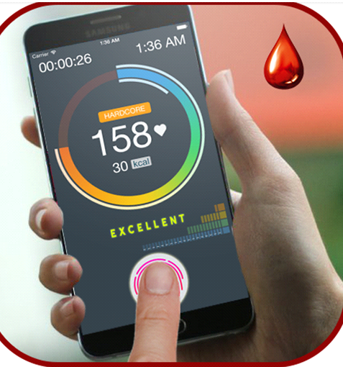

Figure 1.**Blood Sugar Tracker Application**

The study entitled “Blood Sugar Tracker Application” this application is related with this study because it can provide details and reports and to manage the sugar level and keep it under controls diabetic patients.

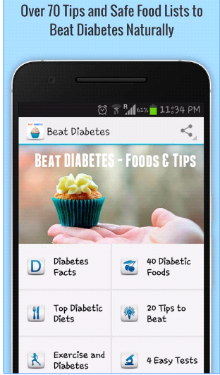

Figure 2. **Beat Diabetes Application**

“Beat Diabetes Application” this application is related to our study because it can give and help the user to monitor their food for their diet tips.

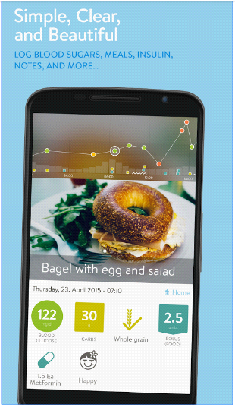

Figure 3. **mySugar Diabetes Logbook application**

“mySugr Diabetes Logbook application” offered by mySugr GmbH it is revealed that this application is related to the proposed study because it can track blood sugar, food, carbs, and weight.

**CHAPTER 3**

**MATERIALS AND METHODS**

**Research Design**

The research study will use the Rapid Application Development method in the creation the application. The proponents believe that this method is applicable in the development of the system. Similarly, a selected group of individuals in which they will be observed and will be surveyed as to the efficiency of this study from the collected data the researchers have. The beneficiary of this study will be the patient and the practitioner.

**Project Environment**

**Locale**

The research of the study will be conducted at AMA Computer College Davao City.

**Population of the study**

The researchers will randomly survey thirty college students of AMA Computer College Davao who will be the respondents of the study.

**Research Instruments**

**Survey questionnaire**

The proponent used a validated questionnaire in gathering data. A questionnaire is a research instrument consisting of a series of questions and other prompts for the purpose of gathering information from the respondents. Although they are often designed for statistical analysis of the responses, this is not always the case.

**Interview questionnaire**

An interview guide was also used to ascertain problems encountered both by the students and teachers.

**Timetable**

This table shows the progress of our research and implementation.

Table1. Gantt chart (September 2017- April 2018)

|  |  |  |  |  |  |  |  |  |  |  |  |  |  |  |  |  |  |  |  |  |
| --- | --- | --- | --- | --- | --- | --- | --- | --- | --- | --- | --- | --- | --- | --- | --- | --- | --- | --- | --- | --- |
| **Activities** | **Online Project Scheduling and Progress Monitoring System** | | | | | | | | | | | | | | | | | | | |
| **SEP** | | | **OCT** | **NOV** | | | | **DEC** | | **JAN** | | **FEB** | | **MAR** | | **APR** | | | |
| **Research** |  | | |  |  | |  | |  | |  | |  | |  | |  | |  | |
| **Planning** |  |  | | | | | |  | |  | |  | |  | |  | |  | |  |
| **Documentation** |  |  |  | | | | | | | | | | | | | | | | |  |
| **Design** |  |  |  | | |  | | | | | | | | | | | | | |  |
| **Implementation** |  |  |  | | |  | |  | | | | | | | | | | | |  |
| **Deployment** |  |  |  | | |  | |  | |  | |  | |  | |  | | | |  |

* Research – On this stage where the researcher gathers data needed in the conduct of the capstone project.
* Planning – The planning stage is where the researchers set a date for every step to be implementing and what to focus for advancing in the capstone project.
* Documentation – The documentation stage is important since all sources maintained and used in this study should be acknowledgement properly.
* Implementation – For this stage, the proponent are going send an email to the respondent for they able to use the application and help the respondent to resolve the current issue problem.
* Deployment – After the system project is completed and approved by the panelist, researchers will install the application to test the application.

**Data Gathering Instruments**

These are the instruments or tools for gathering data in research used as basic for drawing conclusions or making inferences. Some of these tools are interview, questionnaires used by the researchers as they conduct the proposed study.

**Interview**

An Interview is characterized as a meeting of two individuals up close and personal to give about something or a demonstration of addressing to get a fancied answer that is important in taking care of a particular issue. This is the place information gathering happens by making inquiries for tremendously required data from the interviewee verbally and specifically.

**Questionnaire**

This is the most common technique used in energy studies to get data from the specific sample in order to lessen the time needed as compared with the interview. The data that were supplied with the questionnaire was used together with a descriptive method to support the later research instrument.

**Data Gathering Procedures**

In gathering the data for this study, the researchers have done several procedures whicharethe following:

1. Permission.

The researchers will ask permission to the head before conducting the said study.

2. Formulate guide questions.

The researchers will formulate guide question to ask to the respondent or client.

3. Conduct interview

The researcher will conduct an interview to the patient and doctor which is the respondents of the interview.

4. Transcribe interview

The researchers will transcribe a short interview using recorder.

5. Validate transcription

The method is to check that data fall the appropriate parameters defined by the systems analyst. A judgment as to whether data is valid is made possible by the validation program, but it cannot ensure complete accuracy.

**Methodology**

This section contains the following: requirements specification, design, software development, and verification, validation, and testing.

In this section, researchers describes how they come up with the design that been collected by the researchers.

**Requirement Specification**

This document contains instructions and examples which are for the benefit of the person writing the document and should be removed before the document is finalized,

This section includes use-case diagram and use-case specification related to functions of the application.

**USE CASE DIAGRAM**

This section includes use-case diagram and use-case specification related to function of the application**.**

**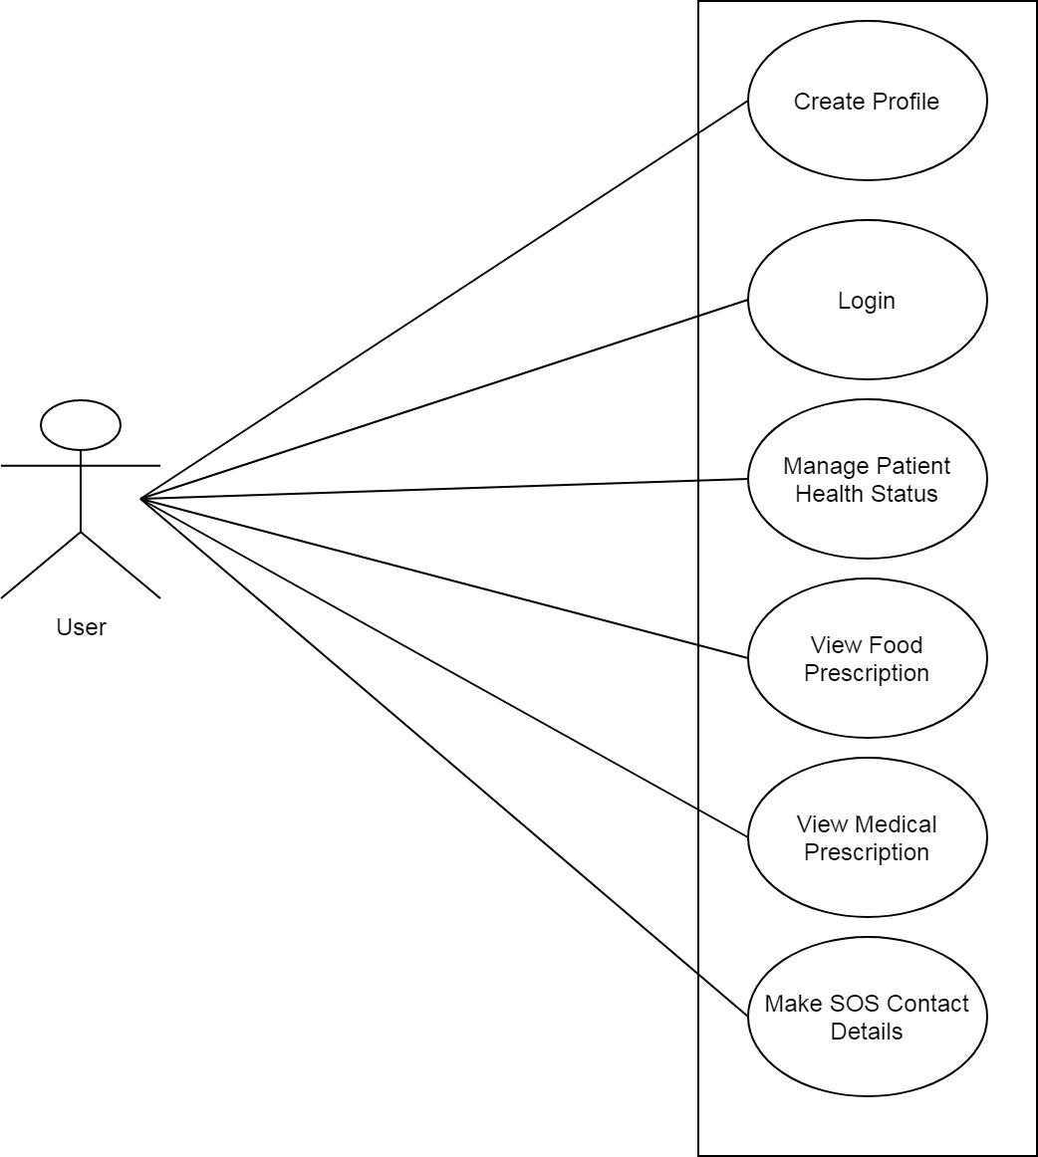**

**Figure 4 –** **Use Case Diagram**

This figure shows the use case diagram of the project.

**USE CASE SPECIFICATION**

**Table 2 Scenario:** **Client can create patient profile**

|  |  |
| --- | --- |
| **ID** | **UC-001** |
| **Title:** | Create profile |
| **Description:** | The client will input personal information to be recorded and stored. |
| **Primary Actor:** | Client |
| **Preconditions:** | The client will create profile. |
| **Post conditions:** | Successfully Create profile |
| **Main Success Scenario:** | bv1. Click “Create profile” button |
| 2. The client will input the full name. |
| 3. The client will input age, first name and last name. |
| 4. The client clicks “Save” button. |
| 5. The system will navigate the client to the home page |
| **Extensions:** | 1. Client will edit necessary info that need to be change and the system will update it |
|  |
| **Frequency of Use:** | Every time client wants to update their profile name. |
| **Status:** | Pending |
| **Owner:** | Client |
| **Priority:** | High |

**Table 3 Scenario:** **Client can create login page**

|  |  |
| --- | --- |
| **ID** | **UC-002** |
| **Title:** | Login Page |
| **Description:** | The client will input their username and password. |
| **Primary Actor:** | Client |
| **Preconditions:** | The client will login |
| **Post conditions:** | Successfully Login |
| **Main Success Scenario:** | 1. The client will input the username and password. |
| 2. The client will click the login button. |
| 3. The system will navigate the client to the home page. |
|  |
|  |
| **Extensions:** | 1. Client can also edit their personal information, like username and password. |
|  |
| **Frequency of Use:** | Every time client wants to update their profile name. |
| **Status:** | Pending |
| **Owner:** | Client |
| **Priority:** | High |

**Table 4 Scenario:** **Client can generate health status**

|  |  |
| --- | --- |
| **ID** | **UC-003** |
| **Title:** | Generate Health Status |
| **Description:** | The client can generate health status |
| **Primary Actor:** | Client |
| **Preconditions:** | Client is logged into the application |
| **Post conditions:** | Client has logged in |
| **Main Success Scenario:** | 1. Client will generate the input blood glucose. |
| 2. Client will generate the input weights. |
| 3. Client will generate the input activity |
| 4. Client will input information |
| 5. System will check all then information and displays |
| **Extensions:** | None |
| **Frequency of Use:** | Every time client wants to update their health status. |
| **Status:** | Pending |
| **Owner:** | Client |
| **Priority:** | High |

**Table 5 Scenario:** **Client can create SOS contact details**

|  |  |
| --- | --- |
| **ID** | **UC-004** |
| **Title:** | Create SOS contact details |
| **Description:** | The client can create SOS contact details. |
| **Primary Actor:** | Client |
| **Preconditions:** | Client is Logged into the application |
| **Post conditions:** | Client has Logged in |
| **Main Success Scenario:** | 1. Client will input the full name of the doctor. |
| 2. Client will input the contact details of the doctor. |
| 3. Client will input the information of the doctor. |
| 4. The application will check the information according to the input details. |
| **Extensions:** | 1. The client will edit the detail if the info needs to be change. |
|  |
| **Frequency of Use:** | Every time client wants to manage the contact details info or update. |
| **Status:** | Pending |
| **Owner:** | Client |
| **Priority:** | High |

**Project Design**

This section includes the context diagram and data flow diagram.

**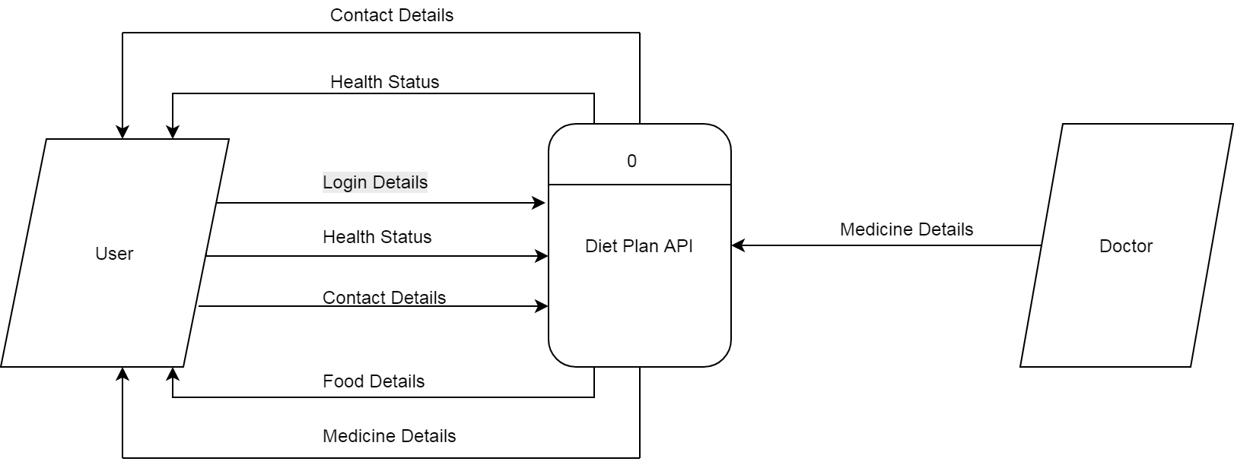**

**Figure 5 –** **Context Diagram**

This figure shows the project design of the application and shows the outgoing data flows linked to participating external entities like user.

**DATA FLOW DIAGRAM**

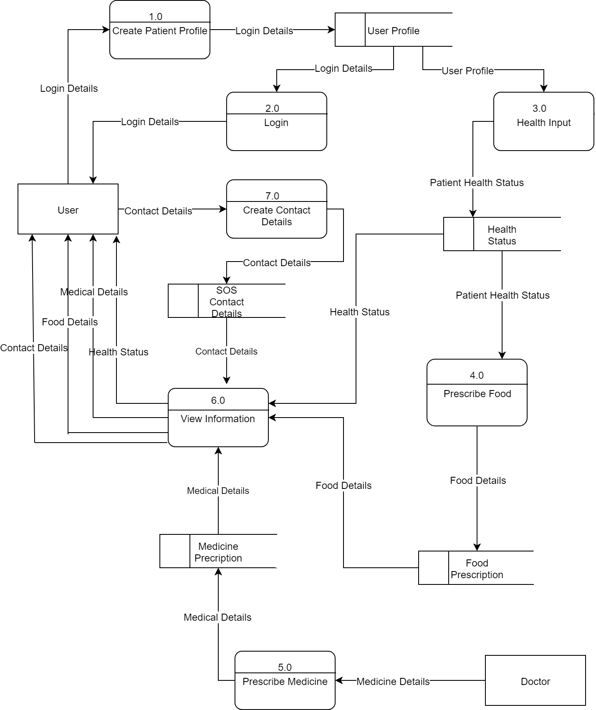 **Figure 6 –** **Data Flow Diagram**

This section will show the multiple process of the application that will used by the client.

**ENTITY RELATIONSHIP DIAGRAM**

This section includes the context diagram and data flow diagram.

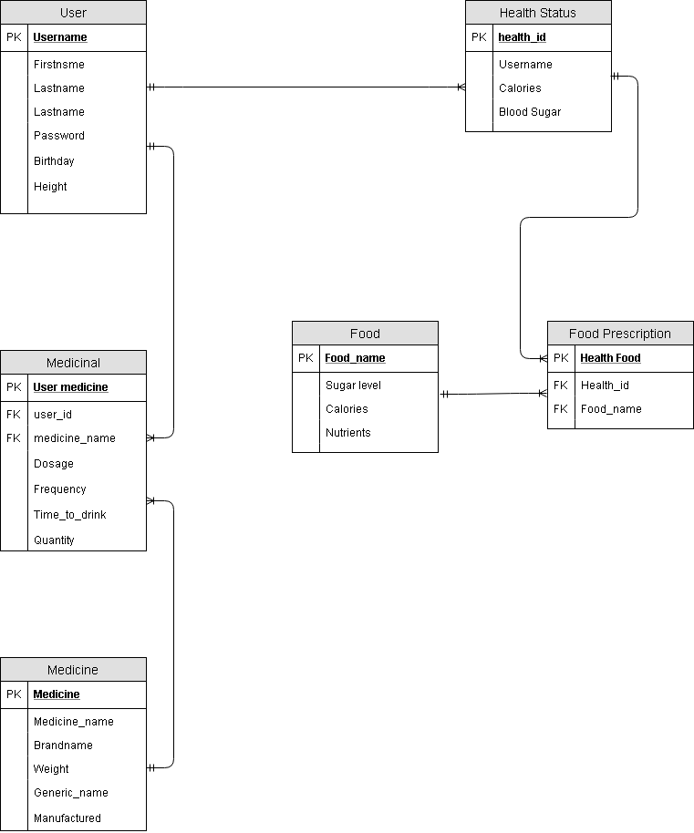

**Figure 7 –** **Entity Relationship Diagram**

**SITE MAP**

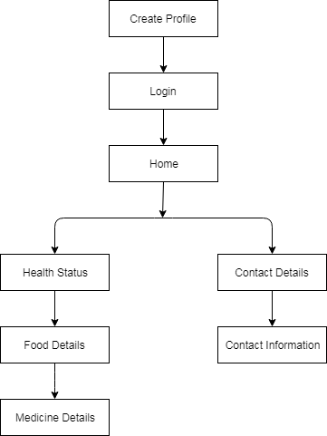

This shows the site map of the application.

**OUTPUT AND USER-INTERFACE DESIGN**

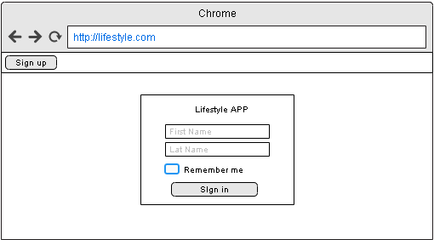

Figure 8 – **Login**

This figure shows the Login section of the application.

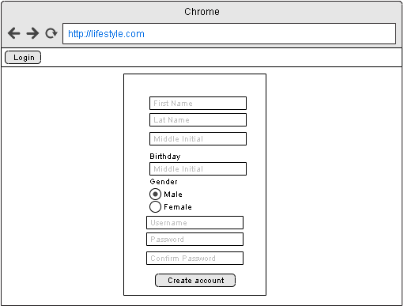

Figure 9 - **Create Profile**

This figure shows the Create Patient Profile section of the application.

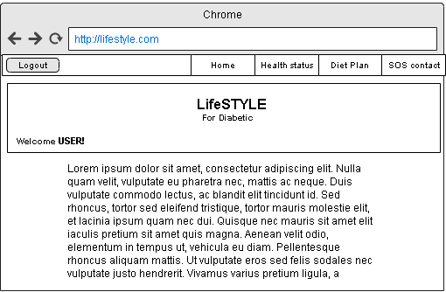

Figure 10 – **Home Page**

This figure shows the home page section of the application.

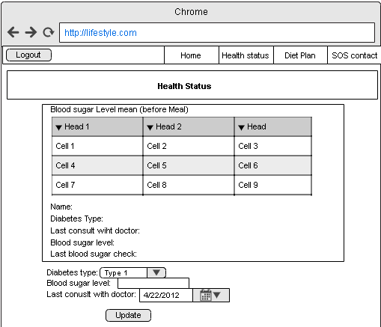

Figure 11 – **Health status**

This figure shows the health status of the user.

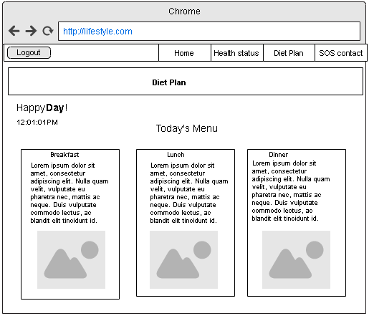

Figure 12 – **Diet Plan**

This figure shows the diet plan for the user.

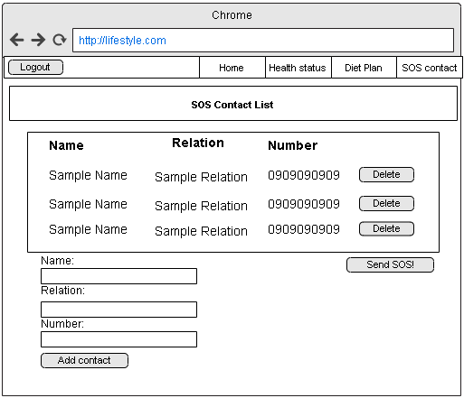

Figure 13 – **SOS contact**

This figure shows the SOS contact List.

**Data Design**

**Data Dictionary**

**Table 6.** **Client Patient Table**

|  |  |  |  |  |  |
| --- | --- | --- | --- | --- | --- |
| **PF** | **Field Name** | **Caption** |  | **Data type** | **Field** |
| PK | CLIENT\_ID | Client ID |  | INTEGER | 11 |
|  | FNAME | First name |  | TEXT | 50 |
|  | LNAME | Last Name |  | TEXT | 50 |
|  | GENDER | Gender |  | TEXT | 50 |
|  | EMAIL\_ADDRESS | Email address |  | TEXT | 50 |
|  | PHONE\_NO | Contact Number |  | TEXT | 50 |

**Table 7. Client Login Table**

|  |  |  |  |  |
| --- | --- | --- | --- | --- |
| **PF** | **Field Name** | **Caption** | **Data type** | **Field** |
| PK | CLIENT\_ID | Client ID | INTEGER | 11 |
|  | USERNAME | username | VARCHAR | 50 |
|  | PASSWORD | password | VARCHAR | 50 |

**Table 8.** **Health Status Table**

|  |  |  |  |  |
| --- | --- | --- | --- | --- |
| **PF** | **Field Name** | **Caption** | **Data type** | **Field** |
| PK | HEALTH\_ID | Health ID | INTEGER | 11 |
|  | HEALTH\_FNAME | First name | TEXT | 50 |
|  | HEALTH\_LNAME | Last Name | TEXT | 50 |
|  | GENDER | Gender | TEXT | 50 |

**Table 9.** **Create SOS Contact Details Table**

|  |  |  |  |  |
| --- | --- | --- | --- | --- |
| **PF** | **Field Name** | **Caption** | **Data type** | **Field** |
| PK | CONTACT\_ID | Contact ID | INTEGER | 11 |
|  | CONTACT\_NAME | Contact Name | TEXT | 50 |
|  | CONTACT\_NUMBER | Contact Number | INTERGER | 11 |
|  | CONTACT\_ADDRESS | Contact Address | TEXT | 50 |

**Table 10.** **View Food Intake Table**

|  |  |  |  |  |
| --- | --- | --- | --- | --- |
| **PF** | **Field Name** | **Caption** | **Data type** | **Field** |
| PK | FOOD\_ID | Intake Food ID | INTEGER | 11 |
|  | FOOD\_NAME | Food Name | TEXT | 50 |

**Table 11.** **View Medicine Intake Table**

|  |  |  |  |  |
| --- | --- | --- | --- | --- |
| **PF** | **Field Name** | **Caption** | **Data type** | **Field** |
| PK | MEDICINE\_ID | Intake Medicine ID | INTEGER | 11 |
|  | MEDICINE\_NAME | Medicine Name | TEXT | 50 |

**Development**

**Software Specification**

The table below is the software specification of the system. It shows the software requirements in order to install and run the system through Android smart phones.

**Table 12-** **Software Specification**

|  |  |
| --- | --- |
| Requirements | Specification |
| OS: Android | 4.2 Jellybean |
| Database storage | SQLite |

**Hardware Specification**

The table below shows the hardware requirements for the system to operate.

**Table 13-** **Hardware specification**

|  |  |
| --- | --- |
| Requirements | Specification |
| Processor: | 1.0 GHz Dual Core |
| Internal/External Storage: | 1GB |
| Memory: | 512 MB RAM |
| WLAN: | Wi-Fi 802.11 a/b/g/n, dual-band |
| Phone | Smartphone (Touch Screen) |

**Deployment Diagram**

The deployment diagram specifies a set of constructs that can be used to define the execution architecture of systems that represent the assignment of software artifacts to nodes. Nodes are connected through communication paths to create network systems of arbitrary complexity.

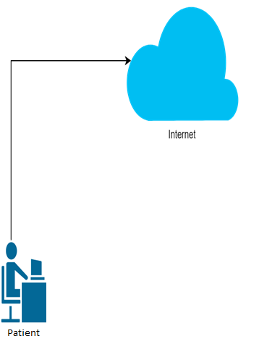

Figure 14-**Deployment Design**

**Test Plan**

**Table 14.** **Create Patient Profile**

|  |  |  |  |  |
| --- | --- | --- | --- | --- |
| **Test Case** | | **TC – 1.0** | | |
| **System:** | | Lifestyle App For Diabetics | | |
| **Designed by:** | | Researchers | | |
| **Executed by:** | | Client | | |
| **Description:** | | Test the create patient profile feature of the system | | |
| **Test Case Name:** | | Create Patient Profile | | |
| **Design Date:** | |  | | |
| **Execution Date:** | |  | | |
|  | |  | | |
| **Pre-condition:** | | The client is not yet creates patient profile in the system. | | |
| **Step** | **Action** | **Expected system response** | **Pass/fail** | **Comment** |
| 1 | Click the “Create Patient Profile” button | The system will display the create profile form. |  |  |
| 2 | Enter a “First Name” | The system will save the first name in the application request. |  |  |
| 3 | Enter a “Last Name” | The system will save the last name in the application request. |  |  |
| 4 | Click “Create Profile” button | The system will display a message successfully create profile. |  |  |
| 5 | Click “Ok” | The system will navigate the newly created client to the system home page section. |  |  |

**Table 15.** **Login page**

|  |  |  |  |  |
| --- | --- | --- | --- | --- |
| **Test Case** | | **TC – 2.0** | | |
| **System:** | | Lifestyle App For Diabetics | | |
| **Designed by:** | | Researchers | | |
| **Executed by:** | | Client | | |
| **Description:** | | Test the login page feature of the system | | |
| **Test Case Name:** | | Login page | | |
| **Design Date:** | |  | | |
| **Execution Date:** | |  | | |
|  | |  | | |
| **Pre-condition:** | | The client is not yet login in the system. | | |
| **Step** | **Action** | **Expected system response** | **Pass/fail** | **Comment** |
| 1 | Enter “Username” | The system will check the username in data base if it is exist |  |  |
| 2 | Enter  “Password | The system will check the password in data base if it is exist. |  |  |
| 5 | Click “Login” | The system will navigate the user to the system home page section. |  |  |

**Table 16.** **Edit Patient Profile**

|  |  |  |  |  |
| --- | --- | --- | --- | --- |
| **Test Case** | | **TC – 3.0** | | |
| **System:** | | Lifestyle App For Diabetics | | |
| **Designed by:** | | Researchers | | |
| **Executed by:** | | Client | | |
| **Description:** | | Test the edit patient profile feature of the system | | |
| **Test Case Name:** | | Edit Patient Profile | | |
| **Design Date:** | |  | | |
| **Execution Date:** | |  | | |
|  | |  | | |
| **Pre-condition:** | | The client is logged in to system | | |
| **Step** | **Action** | **Expected system response** | **Pass/fail** | **Comment** |
| 1 | Click “Welcome Client!” | The system will display an options,  “Edit patient profile” and “Exit” |  |  |
| 2 | Select “Edit patient profile” | .The system will navigate the client the edit patient profile section. |  |  |
| 3 | Select to change the value of the first name | The system will save the first name in the application request. |  |  |
| 4 | Select to change the value of the last name | The system will save the last name in the application request. |  |  |
| 5 | Click “Update” | The system will change save the changes made by the client. |  |  |

**Table 17.** **View Food Intake**

|  |  |  |  |  |
| --- | --- | --- | --- | --- |
| **Test Case** | | **TC – 4.0** | | |
| **System:** | | Lifestyle App For Diabetics | | |
| **Designed by:** | | Researchers | | |
| **Executed by:** | | Client | | |
| **Description:** | | Test the view food intake feature of the system | | |
| **Test Case Name:** | | View Food Intake | | |
| **Design Date:** | |  | | |
| **Execution Date:** | |  | | |
|  | |  | | |
| **Pre-condition:** | | The client is logged in to system | | |
| **Step** | **Action** | **Expected system response** | **Pass/fail** | **Comment** |
| 1 | Click “View food intake” | The system will navigate to the view food intake section of the application |  |  |
| 2 | Click “Home” | The system will navigate the client to the home section of the application |  |  |
| 3 | Click “Menu” | The system will navigate the client to the menu section of the application. |  |  |
| 4 | Click “Back” | The system will navigate the client to the index section of the application. |  |  |

**Table 18.** **Home**

|  |  |  |  |  |
| --- | --- | --- | --- | --- |
| **Test Case** | | **TC – 6.0** | | |
| **System:** | | Lifestyle App For Diabetics | | |
| **Designed by:** | | Researchers | | |
| **Executed by:** | | Client | | |
| **Description:** | | Test the home feature of the system | | |
| **Test Case Name:** | | Home | | |
| **Design Date:** | |  | | |
| **Execution Date:** | |  | | |
|  | |  | | |
| **Pre-condition:** | | The client is logged in to system | | |
| **Step** | **Action** | **Expected system response** | **Pass/fail** | **Comment** |
| 1 | Click “Home” | The system will navigate the client to the home section of the application |  |  |
| 2 | Click “Menu” | The system will navigate the client to the menu section of the application. |  |  |
| 3 | Click “View Reports” | The system will allow the client to view the reports |  |  |
| 4 | Click “Edit Profile” | The system will navigate the client to edit profile section of the application. |  |  |
| 5 | Click “Help” | The system will navigate the client to help section of the application. |  |  |
| 6 | Click “About App” | The system will navigate the client to the about app of the application. |  |  |
| 7 | Click “Logout” | The system will navigate the client to logout section of the application. |  |  |

**Table 19.****View Medicine Intake**

|  |  |  |  |  |
| --- | --- | --- | --- | --- |
| **Test Case** | | **TC – 7.0** | | |
| **System:** | | Lifestyle App For Diabetics | | |
| **Designed by:** | | Researchers | | |
| **Executed by:** | | Client | | |
| **Description:** | | Test the view medicine intake feature of the system | | |
| **Test Case Name:** | | View Medicine Intake | | |
| **Design Date:** | |  | | |
| **Execution Date:** | |  | | |
|  | |  | | |
| **Pre-condition:** | | The client is logged in to system | | |
| **Step** | **Action** | **Expected system response** | **Pass/fail** | **Comment** |
| 1 | Click “View Medicine Intake” | The system will navigate to the view medicine intake section of the application |  |  |
| 2 | Click “Home” | The system will navigate the client to the home section of the application |  |  |
| 3 | Click “Menu” | The system will navigate the client to the menu section of the application. |  |  |
| 4 | Click “Back” | The system will navigate the client to the index section of the application. |  |  |

**Verification, Validation and Testing**

The researchers will verify that the testing was a success based on the complete response of the system. After the system will be approved by the capstone adviser, the researchers will conduct some post implementation of the system within Davao City.

The researchers will test the system in order to identify any system failures and errors. And to trace unnecessary bugs that may occur. The researcher will make several types of test such as testing the software during post implementation phase.

**Unit testing**

The functions and methods of the software for this capstone project should be working fine when it will be tested by the researchers. Other components will also to be tested and checked by the researchers to make sure that it is fully functional and runs accordingly before proceeding to the next step.

**Integration testing**

The researchers will use a testing tool in order to check the bugs and system failures.

**System Testing**

The researchers will check the project to ensure the behavior of the whole system is well tested and defined the scope development. This will include testing based on the requirements, specification, test cases, behavior of the system, and interaction with the operating system and system resources. To ensure that the system verifies well deliver and meets the objectives of the study and its purpose. The researcher will test and investigate both functional and non-functional requirements of the testing.

**CHAPTER 4**

**RESULTS AND DISCUSSION**

This chapter presents the results and discussion from the methods used by the researchers in the previous chapter.

**Project Description**

Diabetes is a chronic illness that requires continuing medical care and ongoing patient self-management education and support to reduce the risk of long-term disability and prevent complications. Lifestyle app for diabetic is a web application system. The system helps users in monitoring their food and medical intake. The system provides diet plan for the user to follow. In addition, the system provides access to some important features such as:

1. Diet Plan
2. Food and medicine intake reminder
3. Sos contact details

**Project Structure**

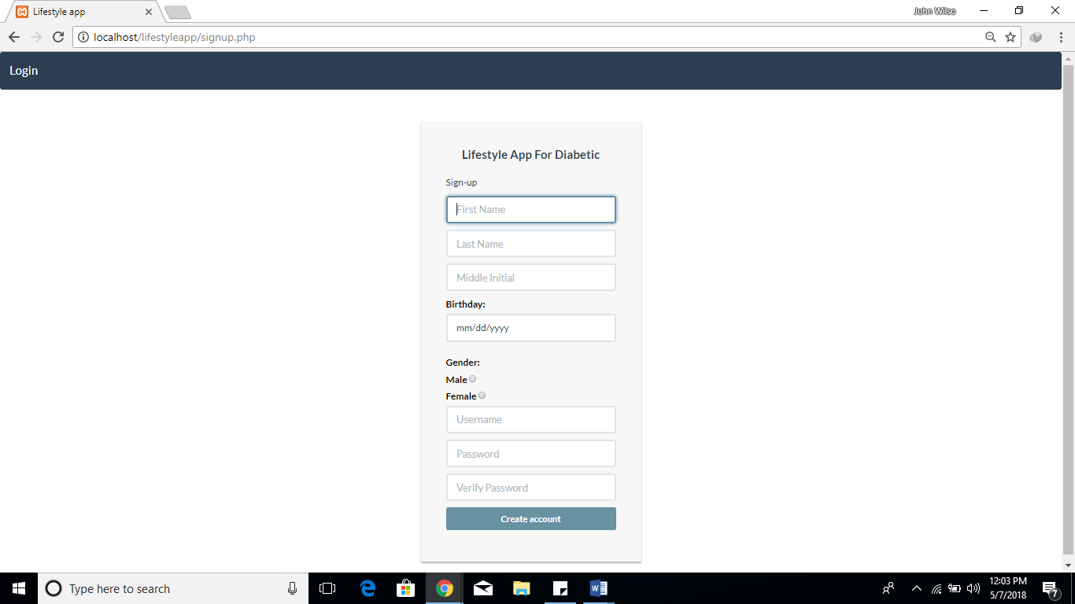

Figure 15-**Register**

Figure 22 shows the registration form of the website.

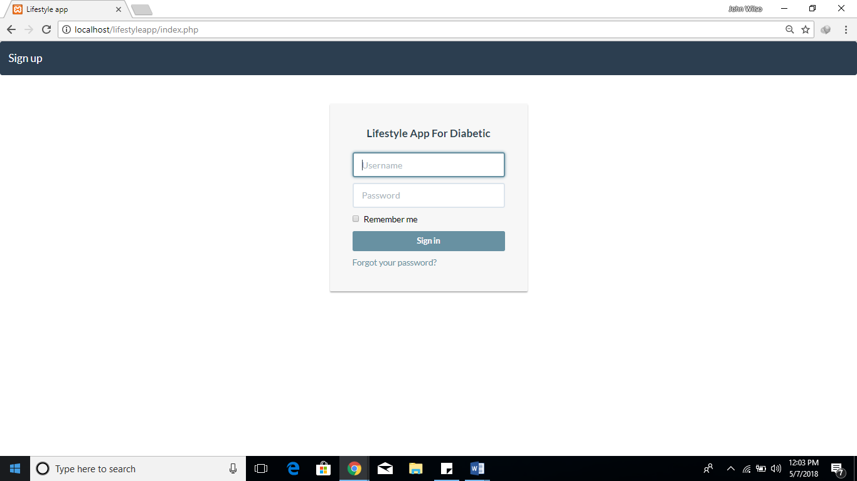

Figure 16- **Login**

Figure 23 provides the login form needed to access the web app.

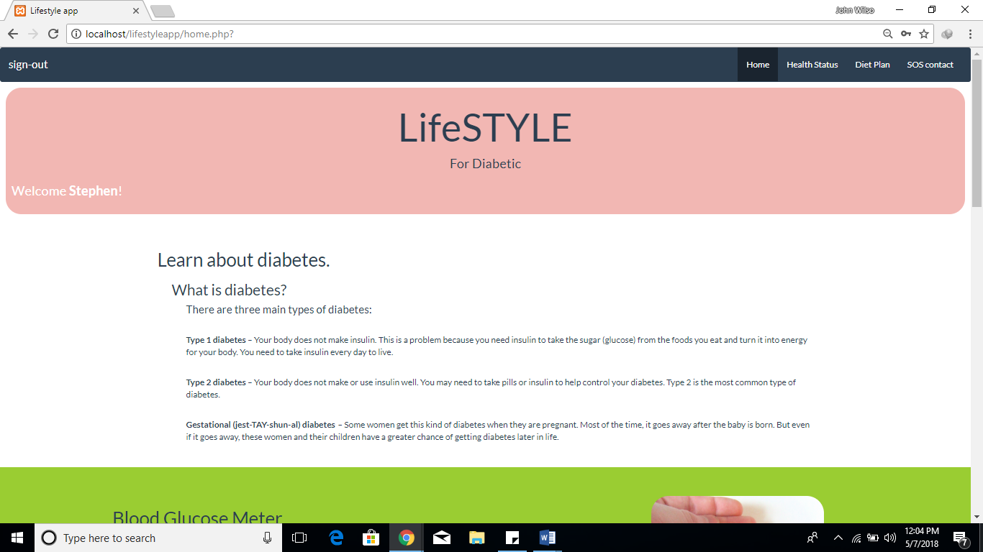

Figure 17-**Home**

The system’s home screen can be seen on figure 24.

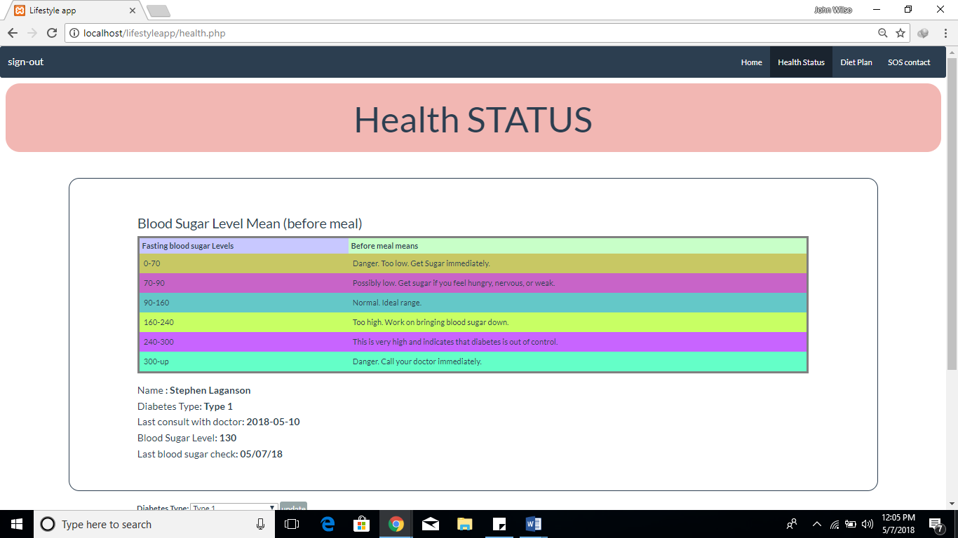

Figure 18**-** **Health status**

Figure 25 shows health status of the patient.

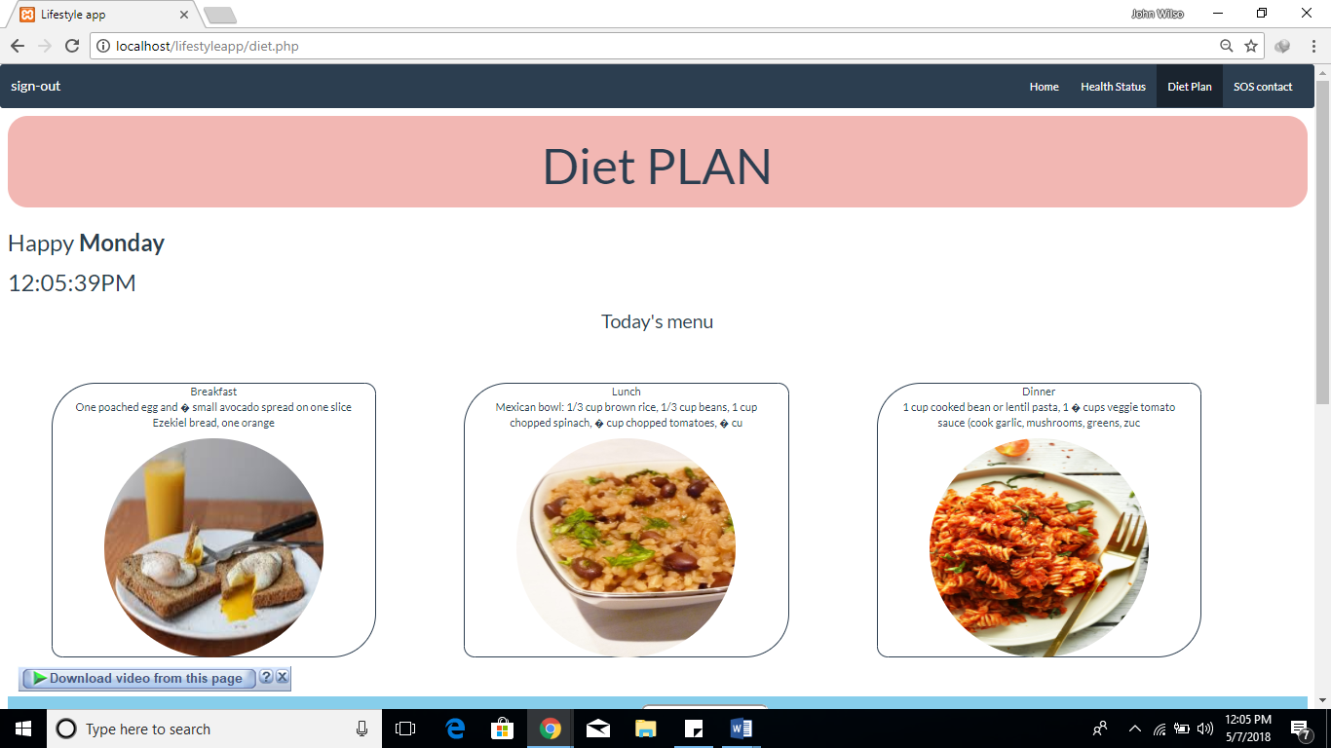

Figure 19-**Diet Plan (Food intake)**

Figure 26 provides the users daily food intake.

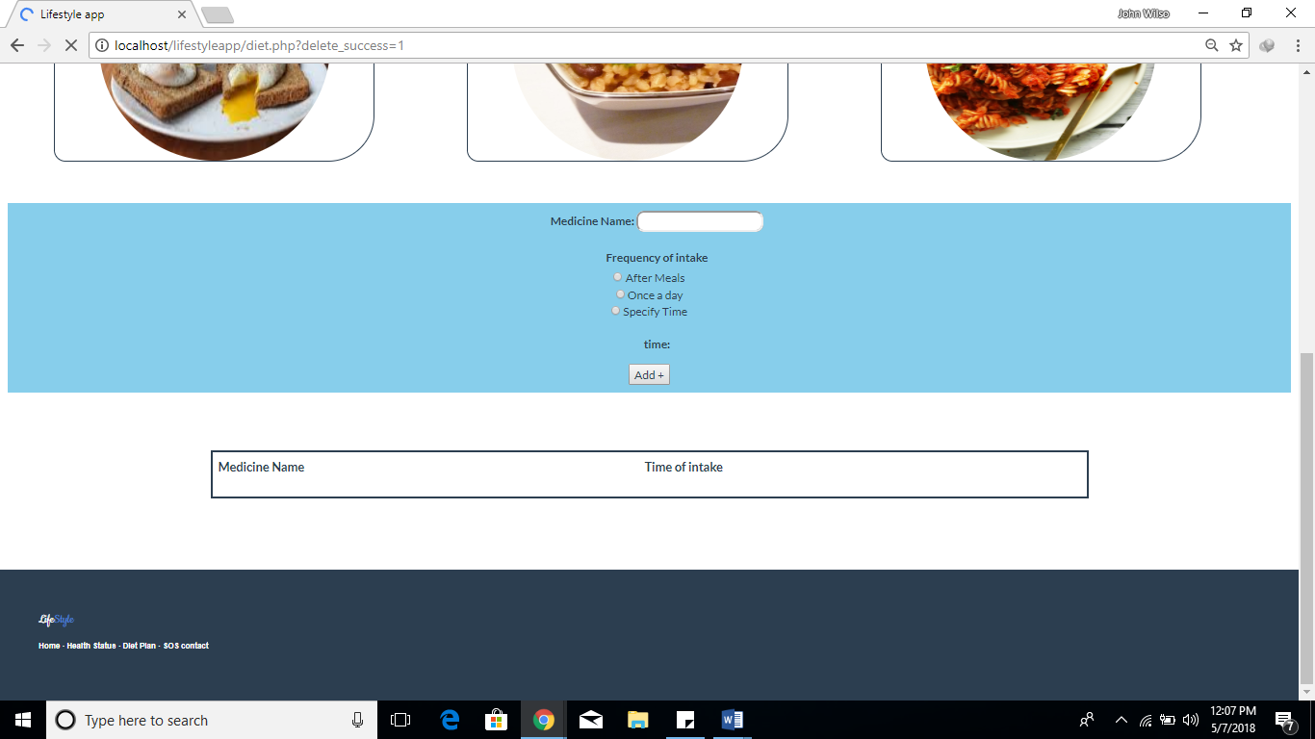

Figure 20**-** **Diet Plan (Medicine intake)**

The list of medicine prescriptions can be seen on figure 27.

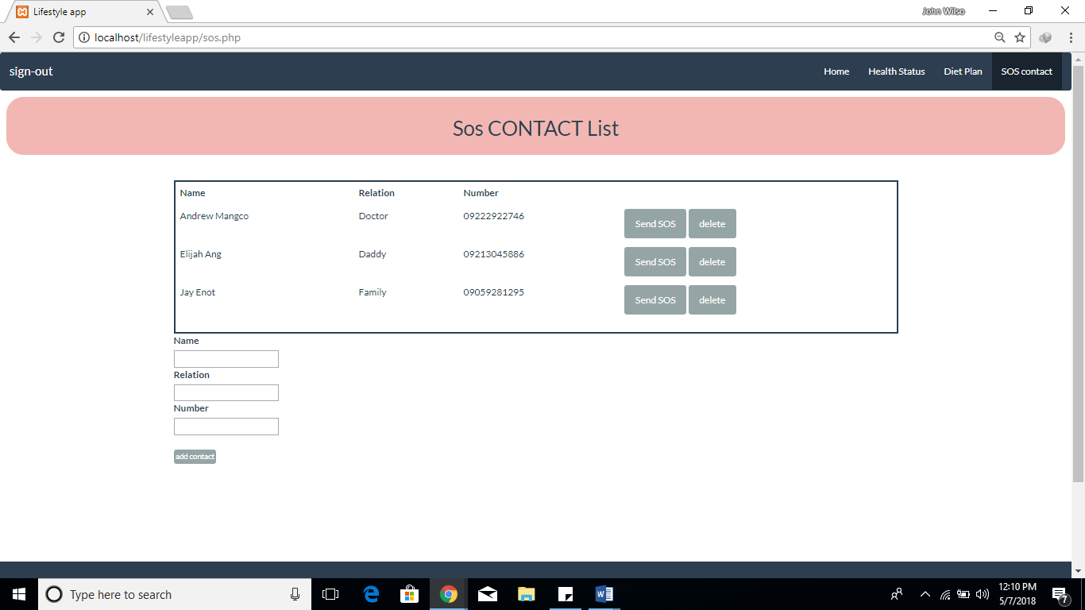

Figure 21**-****SOS contact**

List of SOS contact added can be viewed on figure 28.

**Project and Limitations**

As the system continues to grow, the needs and additional features also rise because of this problem; here are some capabilities and limitations of what the system can do.

**Capabilities:**

1. The system allows user to access a diet plan.
2. The system provides food and medicine intake reminder.
3. The system allows the user to send an SOS message to contacts.

**Limitations:**

The system cannot cover any other physical and medical conditions except diabetic case.

**Project Test Results**

**Test Case**

Test Results No: 1

Test Results Name: Login

Table 20. **Create Patient Profile**

|  |  |  |  |  |
| --- | --- | --- | --- | --- |
| **Test Case** | | **TC – 1.0** | | |
| **System:** | | Lifestyle App For Diabetics | | |
| **Designed by:** | | Researchers | | |
| **Executed by:** | | Client | | |
| **Description:** | | Test the create patient profile feature of the system | | |
| **Test Case Name:** | | Create Patient Profile | | |
| **Design Date:** | |  | | |
| **Execution Date:** | |  | | |
|  | |  | | |
| **Pre-condition:** | | The client is not yet creates patient profile in the system. | | |
| **Step** | **Action** | **Expected system response** | **Pass/fail** | **Comment** |
| 1 | Click the “Create Patient Profile” button | The system will display the create profile form. | pass |  |
| 2 | Enter a “First Name” | The system will save the first name in the application request. | pass |  |
| 3 | Enter a “Last Name” | The system will save the last name in the application request. | pass |  |
| 4 | Click “Create Profile” button | The system will display a message successfully create profile. | pass |  |
| 5 | Click “Ok” | The system will navigate the newly created client to the system home page section. | pass |  |

Test Results No: 1

Test Results Name: Login

Table 21. **Login page**

|  |  |  |  |  |
| --- | --- | --- | --- | --- |
| **Test Case** | | **TC – 2.0** | | |
| **System:** | | Lifestyle App For Diabetics | | |
| **Designed by:** | | Researchers | | |
| **Executed by:** | | Client | | |
| **Description:** | | Test the login page feature of the system | | |
| **Test Case Name:** | | Login page | | |
| **Design Date:** | |  | | |
| **Execution Date:** | |  | | |
|  | |  | | |
| **Pre-condition:** | | The client is not yet login in the system. | | |
| **Step** | **Action** | **Expected system response** | **Pass/fail** | **Comment** |
| 1 | Enter “Username” | The system will check the username in data base if it is exist | pass |  |
| 2 | Enter  “Password | The system will check the password in data base if it is exist. | pass |  |
| 5 | Click “Login” | The system will navigate the user to the system home page section. | pass |  |

Test Results No: 1

Test Results Name: Login

Table 22. **Edit Patient Profile**

|  |  |  |  |  |
| --- | --- | --- | --- | --- |
| **Test Case** | | **TC – 3.0** | | |
| **System:** | | Lifestyle App For Diabetics | | |
| **Designed by:** | | Researchers | | |
| **Executed by:** | | Client | | |
| **Description:** | | Test the edit patient profile feature of the system | | |
| **Test Case Name:** | | Edit Patient Profile | | |
| **Design Date:** | |  | | |
| **Execution Date:** | |  | | |
|  | |  | | |
| **Pre-condition:** | | The client is logged in to system | | |
| **Step** | **Action** | **Expected system response** | **Pass/fail** | **Comment** |
| 1 | Click “Welcome Client!” | The system will display an options,  “Edit patient profile” and “Exit” | pass |  |
| 2 | Select “Edit patient profile” | .The system will navigate the client the edit patient profile section. | pass |  |
| 3 | Select to change the value of the first name | The system will save the first name in the application request. | pass |  |
| 4 | Select to change the value of the last name | The system will save the last name in the application request. | pass |  |
| 5 | Click “Update” | The system will change save the changes made by the client. | pass |  |

Test Results No: 1

Test Results Name: Login

Table 23. **View Food Intake**

|  |  |  |  |  |
| --- | --- | --- | --- | --- |
| **Test Case** | | **TC – 4.0** | | |
| **System:** | | Lifestyle App For Diabetics | | |
| **Designed by:** | | Researchers | | |
| **Executed by:** | | Client | | |
| **Description:** | | Test the view food intake feature of the system | | |
| **Test Case Name:** | | View Food Intake | | |
| **Design Date:** | |  | | |
| **Execution Date:** | |  | | |
|  | |  | | |
| **Pre-condition:** | | The client is logged in to system | | |
| **Step** | **Action** | **Expected system response** | **Pass/fail** | **Comment** |
| 1 | Click “View food intake” | The system will navigate to the view food intake section of the application | pass |  |
| 2 | Click “Home” | The system will navigate the client to the home section of the application | pass |  |
| 3 | Click “Menu” | The system will navigate the client to the menu section of the application. | pass |  |
| 4 | Click “Back” | The system will navigate the client to the index section of the application. | pass |  |

Test Results No: 1

Test Results Name: Login

Table 24. **Home**

|  |  |  |  |  |
| --- | --- | --- | --- | --- |
| **Test Case** | | **TC – 6.0** | | |
| **System:** | | Lifestyle App For Diabetics | | |
| **Designed by:** | | Researchers | | |
| **Executed by:** | | Client | | |
| **Description:** | | Test the home feature of the system | | |
| **Test Case Name:** | | Home | | |
| **Design Date:** | |  | | |
| **Execution Date:** | |  | | |
| **Pre-condition:** | | The client is logged in to system | | |
| **Step** | **Action** | **Expected system response** | **Pass/fail** | **Comment** |
| 1 | Click “Home” | The system will navigate the client to the home section of the application | pass |  |
| 2 | Click “Menu” | The system will navigate the client to the menu section of the application. | pass |  |
| 3 | Click “View Reports” | The system will allow the client to view the reports | pass |  |
| 4 | Click “Edit Profile” | The system will navigate the client to edit profile section of the application. | pass |  |
| 5 | Click “Help” | The system will navigate the client to help section of the application. | pass |  |
| 6 | Click “About App” | The system will navigate the client to the about app of the application. | pass |  |
| 7 | Click “Logout” | The system will navigate the client to logout section of the application. | pass |  |

Test Results No: 1

Test Results Name: Login

Table 25. **View Medicine Intake**

|  |  |  |  |  |
| --- | --- | --- | --- | --- |
| **Test Case** | | **TC – 7.0** | | |
| **System:** | | Lifestyle App For Diabetics | | |
| **Designed by:** | | Researchers | | |
| **Executed by:** | | Client | | |
| **Description:** | | Test the view medicine intake feature of the system | | |
| **Test Case Name:** | | View Medicine Intake | | |
| **Design Date:** | |  | | |
| **Execution Date:** | |  | | |
|  | |  | | |
| **Pre-condition:** | | The client is logged in to system | | |
| **Step** | **Action** | **Expected system response** | **Pass/fail** | **Comment** |
| 1 | Click “View Medicine Intake” | The system will navigate to the view medicine intake section of the application | pass |  |
| 2 | Click “Home” | The system will navigate the client to the home section of the application | pass |  |
| 3 | Click “Menu” | The system will navigate the client to the menu section of the application. | pass |  |
| 4 | Click “Back” | The system will navigate the client to the index section of the application. | pass |  |

**Project Evaluation**

**Implementation Results**

The following are the respondent’s evaluation on the functionality, usability, content and knowledge of the users in Lifestyle app.

Table 26**.** **Indicators**

|  |  |  |
| --- | --- | --- |
| **Indicators** | C:\Users\JOHNPE~1\AppData\Local\Temp\ksohtml\clip_image1.png | Interpretation |
| 1. The mobile application provides a diet plan for diabetic users. | 4.53 | Strongly Agree |
| 2. The mobile application allows users to browse food from a list of prescription. | 4.5 | Strongly Agree |
| 3. The mobile application provides accurate time reminder. | 4.46 | Strongly Agree |
| 4.The mobile application provides food list for their diet. | 4.5 | Strongly Agree |
| 5. The mobile application stores data online. | 4.6 | Strongly Agree |
| 6. The mobile application gives information about food calorie and medicine intake. | 4.5 | Strongly Agree |
| 7. The mobile application automates the time of medicine and food intake. | 4.5 | Strongly Agree |
| 8. The mobile application notifies at the right time of medicine and food intake. | 4.53 | Strongly Agree |
| 9. The mobile application provides useful information. | 4.43 | Strongly Agree |
| 10. The mobile application provides easy access to diet information. | 4.63 | Strongly Agree |
| 11. The mobile application can store emergency contacts. | 4.63 | Strongly Agree |
| 12. The mobile application can send SOS messages to emergency contacts when needed. | 4.63 | Strongly Agree |
| 13. The mobile application aids the doctor in monitoring their patients’ health. | 4.63 | Strongly Agree |
| 14. The mobile application gives access to doctors contact. | 4.63 | Strongly Agree |
| 15. The mobile application allows access to information about their diet plan. | 4.63 | Strongly Agree |
| **Overall** | 4.5 | Strongly Agree |

The respondents’ evaluation on the features of Lifestyle app for diabetic determines that the system meets its system’s objectives. Results show of 4.46 to 4.63 which have a verbal equivalent of Strongly Agree, which means that the system completed and satisfied the users expectations on a lifestyle app.

**CHAPTER 5**

**CONCLUSIONS AND RECOMMENDATIONS**

**Conclusions**

Based on the respondent’s response, the researcher concluded that:

1. The system allows user to access a diet plan.
2. The system provides food and medicine intake reminder.
3. The system allows the user to send an SOS message to contacts.

**Recommendations**

For the future development of the system, the researcher recommends the following features and functions that may help the system to be more reliable and useful to its users.

1. Improve UI design - The system needs to be trendy, the UI design of the system should be updated yet friendly.
2. Blood Sugar meter-The application should be connected to the blood sugar meter.
3. Blood Image processing -Processing the blood color to know the users blood sugar.